**A Different Clustering Algorithm: K-Medoids Implementation and Results**

Isabella Zhu

**K-Medoids**

K-Medoids is an algorithm similar to K-Means that finds clusters based on this heuristic: 

**Results (8 Colors)**

Here are the comparisons for the parrot image: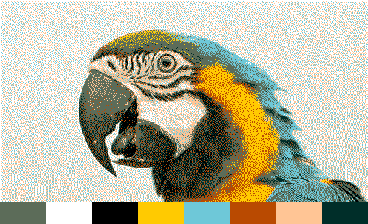

K-Means K-Medoids

And for the other image:





K-Means (top), K-Medoids (bottom)

**Analysis**

K-Medoids is an interesting alternative to K-Means. Some benefits of it is that it converges quickly and also seems to pick brighter colors, which results in a more vibrant and visually appealing result. It also doesn’t depend on the assumption that clusters are of similar size. On the other hand, it doesn’t represent colors as accurately as K-Means does and also takes longer to run.

One detail that K-Medoids gets better than K-Means is that it doesn’t put red on the mountain. Notice that in the K-Means image there is a lot of pink on the mountain, which is inaccurate, but K-Medoids avoids this problem.

To summarize, K-Medoids is not significantly better or worse than K-Means, but while K-Means chooses the average color, K-Medoids chooses the brightest ones. It is a viable vector tokenization option depending on the usage of the tokenized image.